AN EXPLAINABLE MACHINE LEARNING APPROACH WITH DENSITY-REGULARIZED OVERSAMPLING FOR INDUSTRIAL CUSTOMER CHURN PREDICTION

PROJECT OVERVIEW
This project focuses on predicting customer churn using machine learning and Explainable AI. Customer churn is difficult to predict because churn customers are usually fewer than non-churn customers, creating a class imbalance problem. The proposed system introduces a Density-Regularized SMOTE-ENC technique that generates synthetic churn samples and filters them using local data density to remove noisy and overlapping samples. Machine learning models are then trained on the improved dataset, and LIME and SHAP are used to explain the predictions. The framework is evaluated on banking, telecommunications, and retail churn datasets.

EXISTING SYSTEM
- Uses traditional machine learning and standard oversampling techniques for customer churn prediction.
- SMOTE and SMOTE-ENC are commonly used to handle the imbalance between churn and non-churn customers.
- Machine learning models are used to predict churn based on customer demographic, service, and behavioral information.

DRAWBACKS OF EXISTING SYSTEM
- Standard oversampling may generate noisy or unrealistic synthetic churn samples.
- Synthetic samples can be created close to majority-class regions, causing class overlap.
- Class imbalance can reduce the model’s ability to correctly identify churn customers.
- Conventional models may provide limited explanation about why a customer is predicted to churn.

PROPOSED SYSTEM
- Uses Density-Regularized SMOTE-ENC to generate and filter synthetic minority-class samples according to local data density.
- Applies machine learning classifiers to the improved and balanced churn datasets.
- Uses LIME and SHAP to explain predictions and identify important factors affecting customer churn.

ADVANTAGES OF PROPOSED SYSTEM
- Reduces noisy and overlapping synthetic samples during oversampling.
- Improves the identification of minority-class churn customers.
- Provides better and more reliable churn prediction across different business sectors.
- Provides interpretable predictions that can support customer retention decisions.

PROJECT WORKFLOW

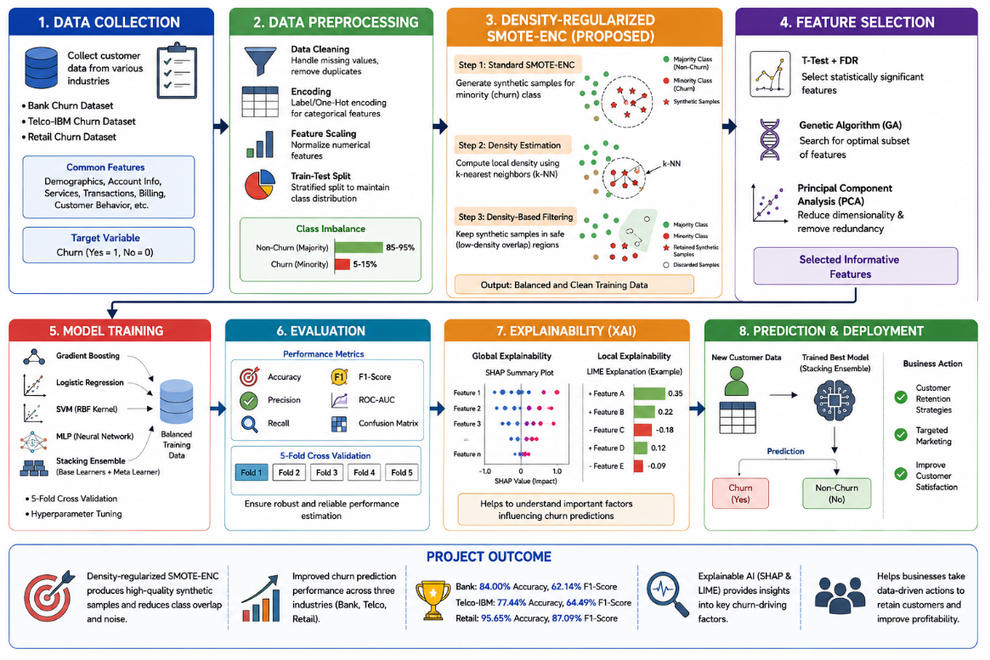

ALGORITHMS USED
S.NO | ALGORITHMS | DESCRIPTION
1. | Density-Regularized SMOTE-ENC | Generates synthetic churn samples and filters them using local density to retain reliable samples near the minority class.
2. | Gradient Boosting | Combines multiple decision trees to learn complex customer churn patterns.
3. | Logistic Regression | Predicts the probability of a customer belonging to the churn or non-churn class.
4. | Support Vector Machine (SVM) | Separates churn and non-churn customers using an RBF kernel for nonlinear patterns.
5. | Stacking Ensemble | Combines Logistic Regression, SVM, and MLP predictions to improve overall churn classification.
These are selected from the paper's proposed oversampling and downstream classification framework. The paper reports that Stacking Ensemble performs best overall, while the best classifier varies by dataset.

PROJECT OUTCOME
- Developed an explainable customer churn prediction framework for banking, telecommunications, and retail sectors.
- The proposed method achieved 84.00% accuracy and 62.14% F1-score on Bank Churn, 77.44% accuracy and 64.49% F1-score on Telco-IBM, and 95.65% accuracy and 87.09% F1-score on Retail Churn.
- Density-aware oversampling improved churn prediction by generating higher-quality minority samples and reducing class overlap and noise.

